RÉPUBLIQUE ALGERIENNE DÉMOCRATIQUE ET POPULAIRE MINISTÈRE DE L’ENSEIGNEMENT

SUPÉRIEUR ET DE LA RECHERCHE SCIENTIFIQUE

UNIVERSITÉ DES SCIENCES ET DE LA TECHNOLOGIE HOUARI BOUMEDIENE

FACULTÉ DES MATHÉMATIQUES

­­­­

**­­**

**F**aculté of Computer Science

**Technologies of information and communication**

Directed by:

GRAIA Ramine Mohammed Ryad

KENAZA Mouataz

DJAAFRI Haithem

SAIDOUNI Djoulene

RAHLI Zineddine

Academic year : 2023/2024

**I. Introduction**

In the ever-expanding landscape of Information and Communication Technologies (ICT), certain giants have emerged, shaping the digital contours of our world. This report navigates the intricate ecosystem of Google services, Microsoft tools, Git, and GitHub, each representing a cornerstone in the technological mosaic that underpins contemporary digital interactions. Throughout this exploration, we will conduct a thorough comparative analysis, dissecting the functionalities, impact, and collaborative dynamics of these entities. From the ubiquitous reach of Google’s suite to the productivity arsenal of Microsoft, and the collaborative prowess of Git and GitHub in software development, we aim to unravel the distinctive features that define each, offering insights into their respective strengths and contributions to the interconnected fabric of our digital age.



**II. Characteristics of Information and Communication Technologies**

|  |  |
| --- | --- |
| Characteristic | Description |
| Ubiquity | Pervasive presence, widely accessible across various aspects of life, work, and society. |
| Interconnectivity | Facilitates communication and connection between different devices, systems, and networks. |
| Convergence | Integration of traditionally distinct technologies, such as telecommunications and computing |
| Digitization | Information is represented in digital form, enabling easy storage, manipulation, and transfer |
| Automation | Enables the automation of processes and tasks, reducing the need for manual intervention |
| Multifunctionality | ICT systems often serve multiple functions, combining diverse capabilities |

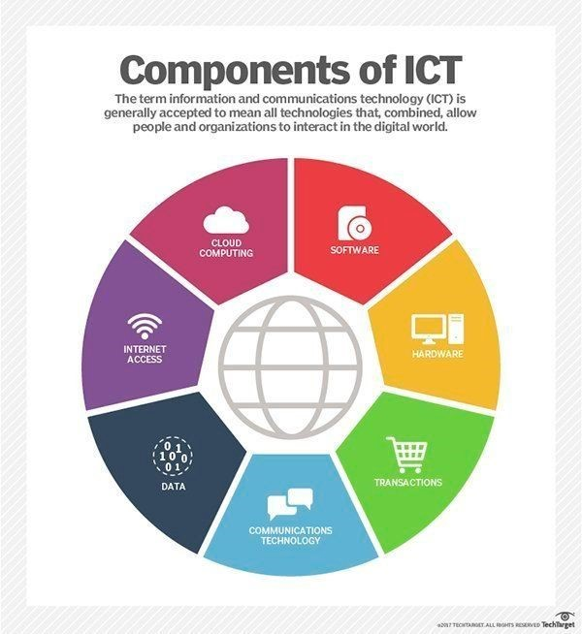

**III. Introducing TIC services**

* **analysis of google services**
* **definitions google services**

Google offers a comprehensive suite of services that have become integral parts of the digital experience. Google Search, the company's flagship search engine, remains a ubiquitous tool for information retrieval. Gmail, one of the most widely used email services globally, provides users with a feature-rich platform for communication. Google Maps offers mapping and navigation services, while Google Drive enables seamless cloud storage and file sharing. The suite extends to productivity tools like Google Docs, Sheets, and Slides, fostering collaborative document creation. Google Calendar aids in efficient time management and scheduling, and Google Photos simplifies the organization and storage of multimedia content. The Chrome web browser stands out for its speed and integration with Google services. Google Translate facilitates language translation, and Google Assistant employs artificial intelligence to assist users through voice interactions. YouTube, a Google-owned platform, dominates the realm of video sharing. Services like Google Classroom support online learning, and Google Ads and Analytics empower businesses with online advertising tools and detailed web analytics. This diverse array of services collectively shapes the digital landscape, catering to the diverse needs of users across the globe.

* **a list of different services offered by Google:**
* **Google Search:** A powerful search engine for finding information online
* **Gmail:** An e-mail service with a user-friendly interface and large storage capacity.
* **Google Drive:** A service for storing files online and sharing them with other users.
* **Google Docs, Sheets, Slides:** Online office applications similar to Microsoft Word, Excel and PowerPoint, for creating, editing and sharing documents, spreadsheets and presentations.



**IV. Exploring Microsoft Tools**

* **Software applications:**
* **Microsoft Office Suite:**
* Microsoft’s Office package includes software such as Word, Excel, PowerPoint, Outlook and OneNote, used by both businesses and the general public for document creation, presentations, e-mail management and more.
* **Power BI:**
* A data analysis tool enabling companies to visualize and share insights from their data to make informed decisions.
* **Visual Studio:**
* An integrated development environment (IDE) for creating applications and software solutions.
* **SharePoint:**
* An enterprise content management platform that makes it easy to store, share and collaborate on documents and information
* **Influence on professional and personal life:**

Microsoft has had a major impact on business and personal environments through the widespread adoption of its technologies and services. Here’s how Microsoft has influenced these areas:

* **Professional environment:** Microsoft Office has become a key productivity tool for businesses worldwide. The Office suite is widely used for document creation, presentations, e-mail management and more. In addition, the Microsoft Teams collaboration platform has transformed the way teams work together, offering unified communication, file sharing and real- time collaboration capabilities.
* **Personal environment:** Microsoft software such as the Windows operating system, the Office suite and entertainment tools like the Xbox have had a significant impact on users’ daily lives. In addition, Microsoft has extended its presence with products such as Skype for personal and business communications.

Contributing to global TIC development Microsoft has played a key role in global technological development through a number of initiatives, including:

* **Strategic partnerships:** Microsoft has established partnerships with other leading technology companies and start-ups, fostering innovation in key areas such as AI, cloud computing, IoT and cybersecurity.
* **Investment in research and development:** Microsoft has in- vested heavily in research and development, particularly in emerging fields such as quantum computing, biotechnology and artificial intelligence, contributing to the advancement of these technologies.

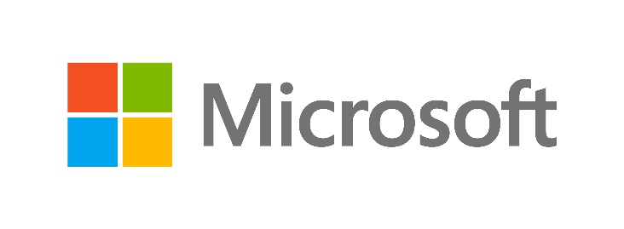

**V. Git/GitHub analysis**

* **understanding git/GitHub relation to TIC**

Git and GitHub play pivotal roles in the Information and Communication Technologies **(TIC)** landscape, particularly in the realm of software development. Git, as a distributed version control system, enables efficient tracking of code changes, fostering collaboration among multiple developers simultaneously. GitHub, built around Git, serves as a centralized platform for hosting code repositories, facilitating collaborative development, issue tracking, and documentation. This combination streamlines project management, making it an essential tool for distributed teams working on complex software projects. The integration of Git and GitHub supports continuous integration and deployment **(CI/CD)**, ensuring automated testing and reliable deployment of code changes. Moreover, GitHub's role in open-source collaboration has become instrumental in the global TIC community, providing a space for developers worldwide to contribute to and improve open-source projects. The platform's features for code review, documentation, and project management contribute to enhancing code quality, knowledge sharing, and efficient coordination in the dynamic and fast-paced field of TIC.

* **impact of Git/GitHub on TIC**

Git and GitHub have significantly impacted the landscape of Information and Communication Technologies **(TIC)** by revolutionizing the methodologies and practices in software development. The introduction of Git's distributed version control system has streamlined collaborative development, allowing multiple developers to work on projects concurrently while efficiently managing changes, branches, and code versions. GitHub, as a centralized platform built around Git, has provided a cohesive space for hosting repositories, enabling efficient collaboration, project management, and issue tracking. The integration of CI/CD tools with Git on platforms like GitHub has automated testing and deployment processes, ensuring the reliability and efficiency of software applications in the TIC domain. Additionally, GitHub's role as a global hub for open-source collaboration has accelerated innovation by fostering a community where developers worldwide can contribute to and improve software projects. The transparency, visibility, and documentation features of Git and GitHub further enhance project management, knowledge transfer, and code quality in the dynamic and fast-paced field of TIC.



**VI. TIC and his social impact**

Information and Communication Technologies **(TIC)** have had a profound social impact, reshaping the way individuals interact, access information, and participate in various aspects of modern society. The advent of global connectivity has transformed communication dynamics, fostering a more interconnected and globalized world. Social media platforms, integral components of TIC, have become pivotal in shaping personal and collective narratives, offering instantaneous communication and the formation of virtual communities. TIC democratization of information access has empowered individuals with a wealth of knowledge, contributing to widespread education and awareness. Moreover, the digital economy, facilitated by TIC, has generated new economic opportunities, altered traditional business models and created avenues for entrepreneurship. However, the social impact of TIC is not without challenges, as privacy concerns, cybersecurity issues, and the digital divide necessitate careful consideration. Despite these challenges, TIC has played a pivotal role in fostering cultural exchange, enabling social activism, revolutionizing education, and advancing healthcare, exemplifying its multifaceted and transformative influence on the fabric of contemporary society.

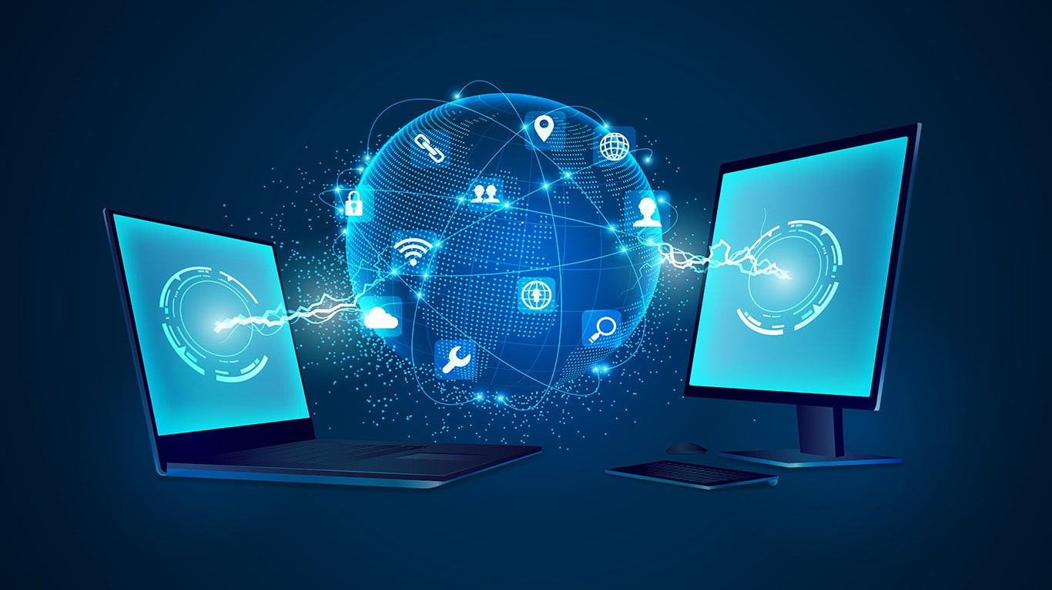

**VII. Future trends of TIC**

The future trends of Information and Communication Technologies **(TIC)** promise a dynamic and transformative landscape. The imminent rollout of 5G networks is poised to revolutionize communication, unlocking the full potential of applications like Internet of Things **(IoT)**, augmented reality **(AR)**, and virtual reality **(VR)**. Artificial Intelligence **(AI)** and Machine Learning **(ML)** are anticipated to advance further, permeating various sectors with smarter and adaptive systems. Edge computing is gaining traction for its ability to process data closer to its source, reducing latency. Blockchain technology is expected to extend beyond cryptocurrencies, finding applications in supply chain management and secure data sharing. The advent of quantum computing holds promises for solving complex problems at an unprecedented speed. Extended Reality **(XR)**, encompassing AR, VR, and mixed reality, is anticipated to play an increasingly integral role in sectors ranging from gaming to healthcare. Cybersecurity innovations will remain paramount, addressing evolving digital threats with advanced detection mechanisms and artificial intelligence-driven security measures. Human augmentation technologies, such as wearables and brain-machine interfaces, are likely to gain prominence in healthcare and industries requiring physical augmentation. The integration of TIC with a focus on sustainability is expected to grow, supporting eco-friendly practices and addressing environmental concerns. As TIC continues to evolve, these trends underscore the ongoing fusion of technology into diverse facets of our lives, promising both challenges and unprecedented opportunities.

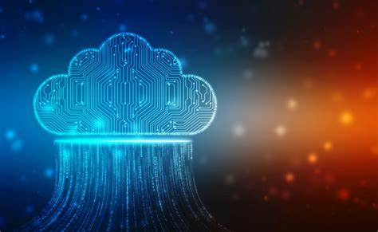

**VIII. Conclusion**

In conclusion, the landscape of Information and Communication Technologies (ICT) is undergoing a profound transformation, marked by dynamic advancements and emerging trends. The integration of 5G networks, artificial intelligence, and edge computing is poised to redefine the way we communicate and interact with technology. Blockchain technology holds promise for secure and transparent data management, while quantum computing and extended reality are opening new frontiers in computation and immersive experiences. As the digital realm evolves, the importance of cybersecurity, sustainability, and human augmentation becomes increasingly apparent. The ongoing synergy of these technological trends reflects a future where ICT continues to shape and enhance various aspects of our personal, professional, and societal experiences. Navigating this evolving landscape requires a keen awareness of these trends, ensuring that individuals, businesses, and societies are well-equipped to harness the full potential of Information and Communication Technologies in the years to come.